**Team 04 Flight-Booking System**

Jing Yang, Jiang Miao, Fu Zhan, Bin Yu

**1. System environment**

Platform: Eclipse Luna Service Release 1a (4.4.1); JDK 1.8.0_31; Tomcat V8.0

**2. Package description**

|  |  |
| --- | --- |
|  | Package “entity”  Contain the class of airport, airplane and the flight. Provide the basic information of the system  Package “functions”  Contain the class of search flight, provide the function of search.  Package “interactWithServer”  Contain all the class which need to get data from the back-end database server, lock database, unlock database, write data to the database, and reset database.  Package ”parseXMLString”  Parse the xmlString return by back-end database server  Package “timeRelated”  Functions related to change time format, and match time with specific time zones. |

**3. Functions we have implemented:**

Search flights (one-way/round-trip) between two airports without stopovers.

Book flights (one-way/round-trip)

Display flights that customer have booked.

**Functions we are going to implement:**

Search flights with stopovers, display time in the time zone according to the latitude and longitude of the airport, filter the searched results according to specified time window and numbers of stopovers, and sort the searched results in specific ways

**4. Description of team member roles**

**Jing Yang:**

Designing the core code of connection with the server. Including write the function URL code, parse the XML string form the server, design the basic data structure of the system Responsible for the server can normally process different kind requirements from the system.

**Jiang Miao:**

Responsible for write the basic functional code of booking and searching. Designing the core code of parse and get XML code from the server to ensure the system can achieve data to accomplish the basic function.

**Fu Zhan:**

Responsible for the actual building and massive structure of the system. Designing the interface of whole system and provide the function plugins to make the interface more humanization.

**Bin Yu:**

To ensure that the system meets all the class requirements and that it is free of errors and defects. Finding the bugs of system and write the document of the system introduction.

**4. Verify data loop in the system.**

**Input**

If we input the flight information that the serve database doesn’t contain, the result will be

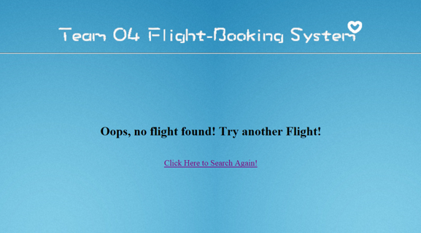

There are two kind of ticket type:

**One way:**

a. Choosing the basic searching information:

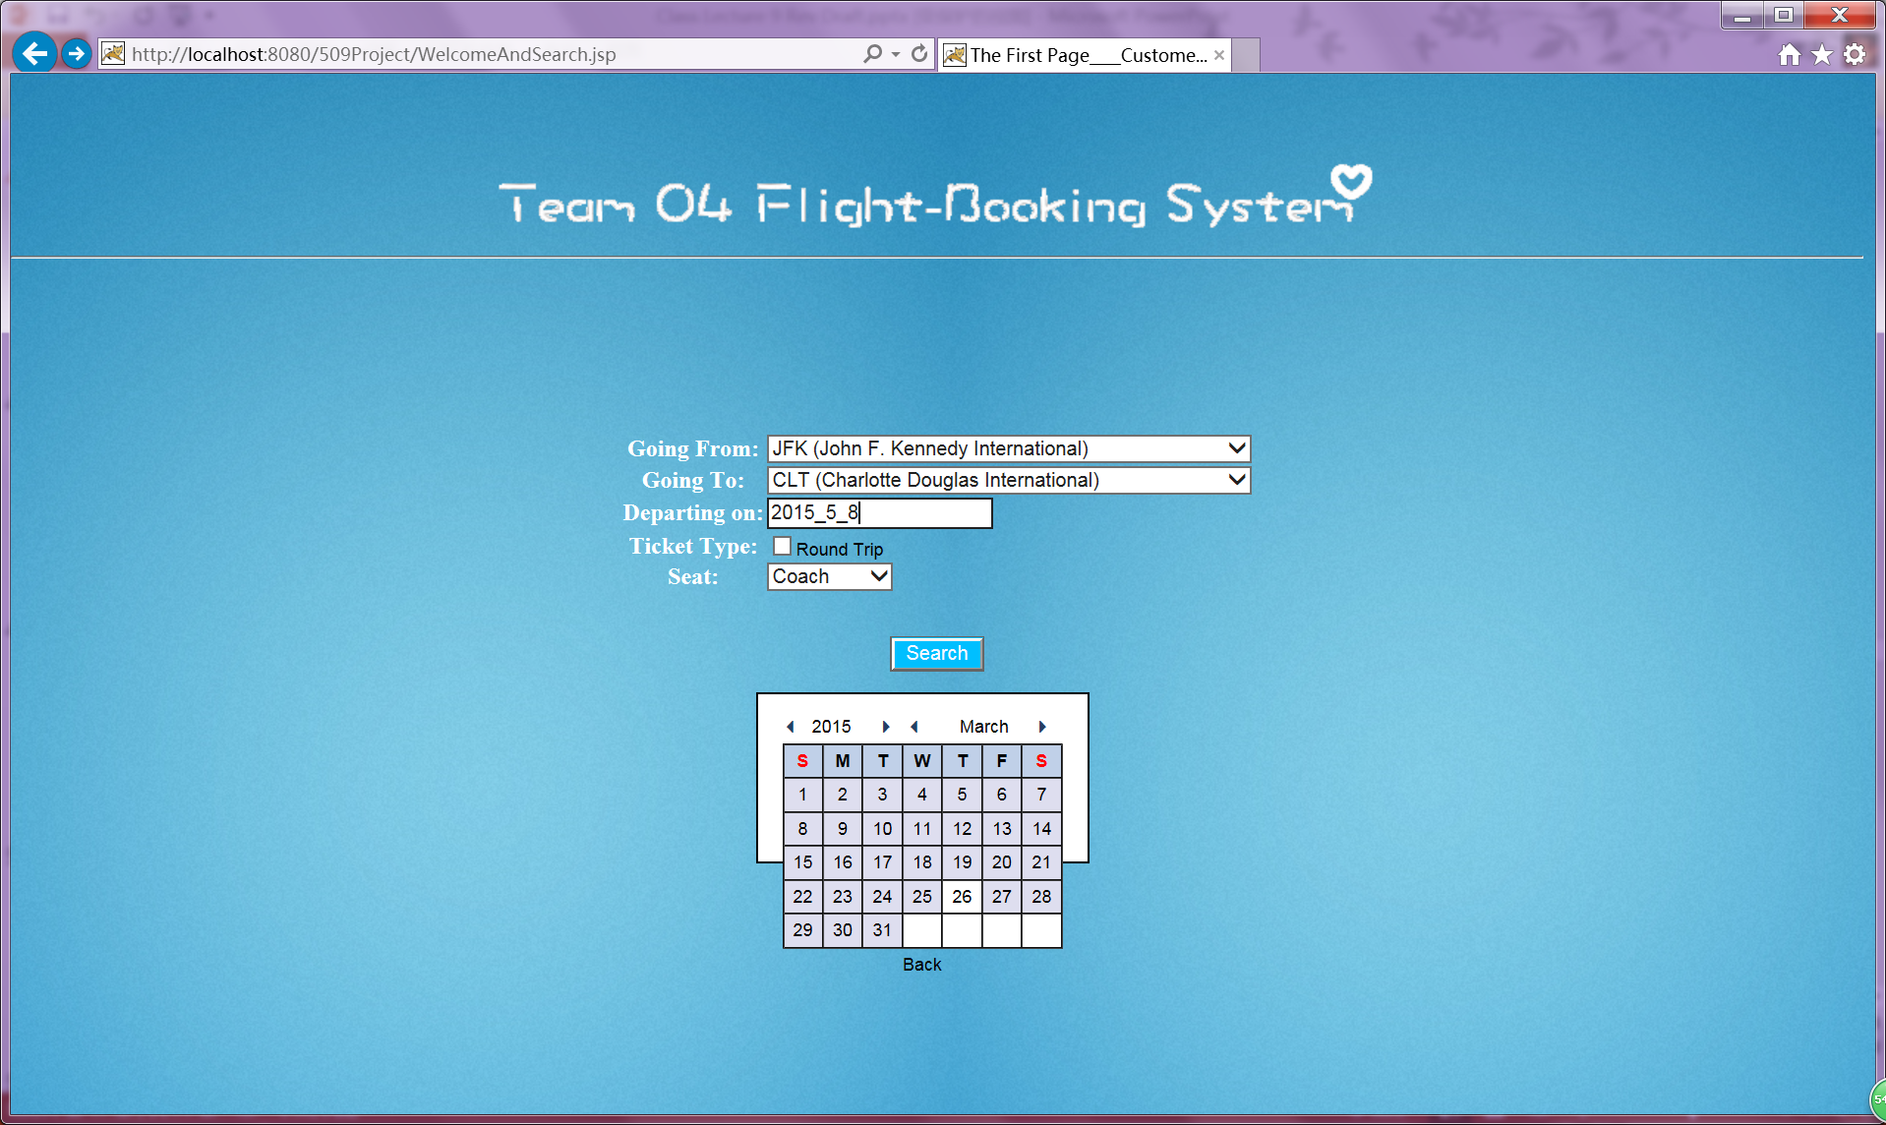

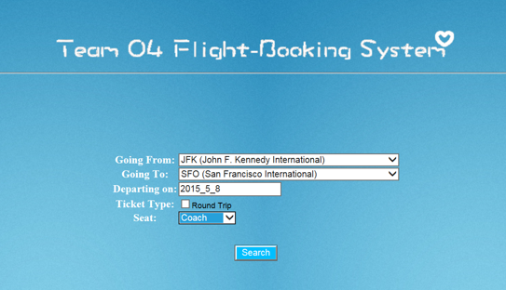

b. Booking the flight:

We can choose the first one and we find the coach seat number of this flight is 179.

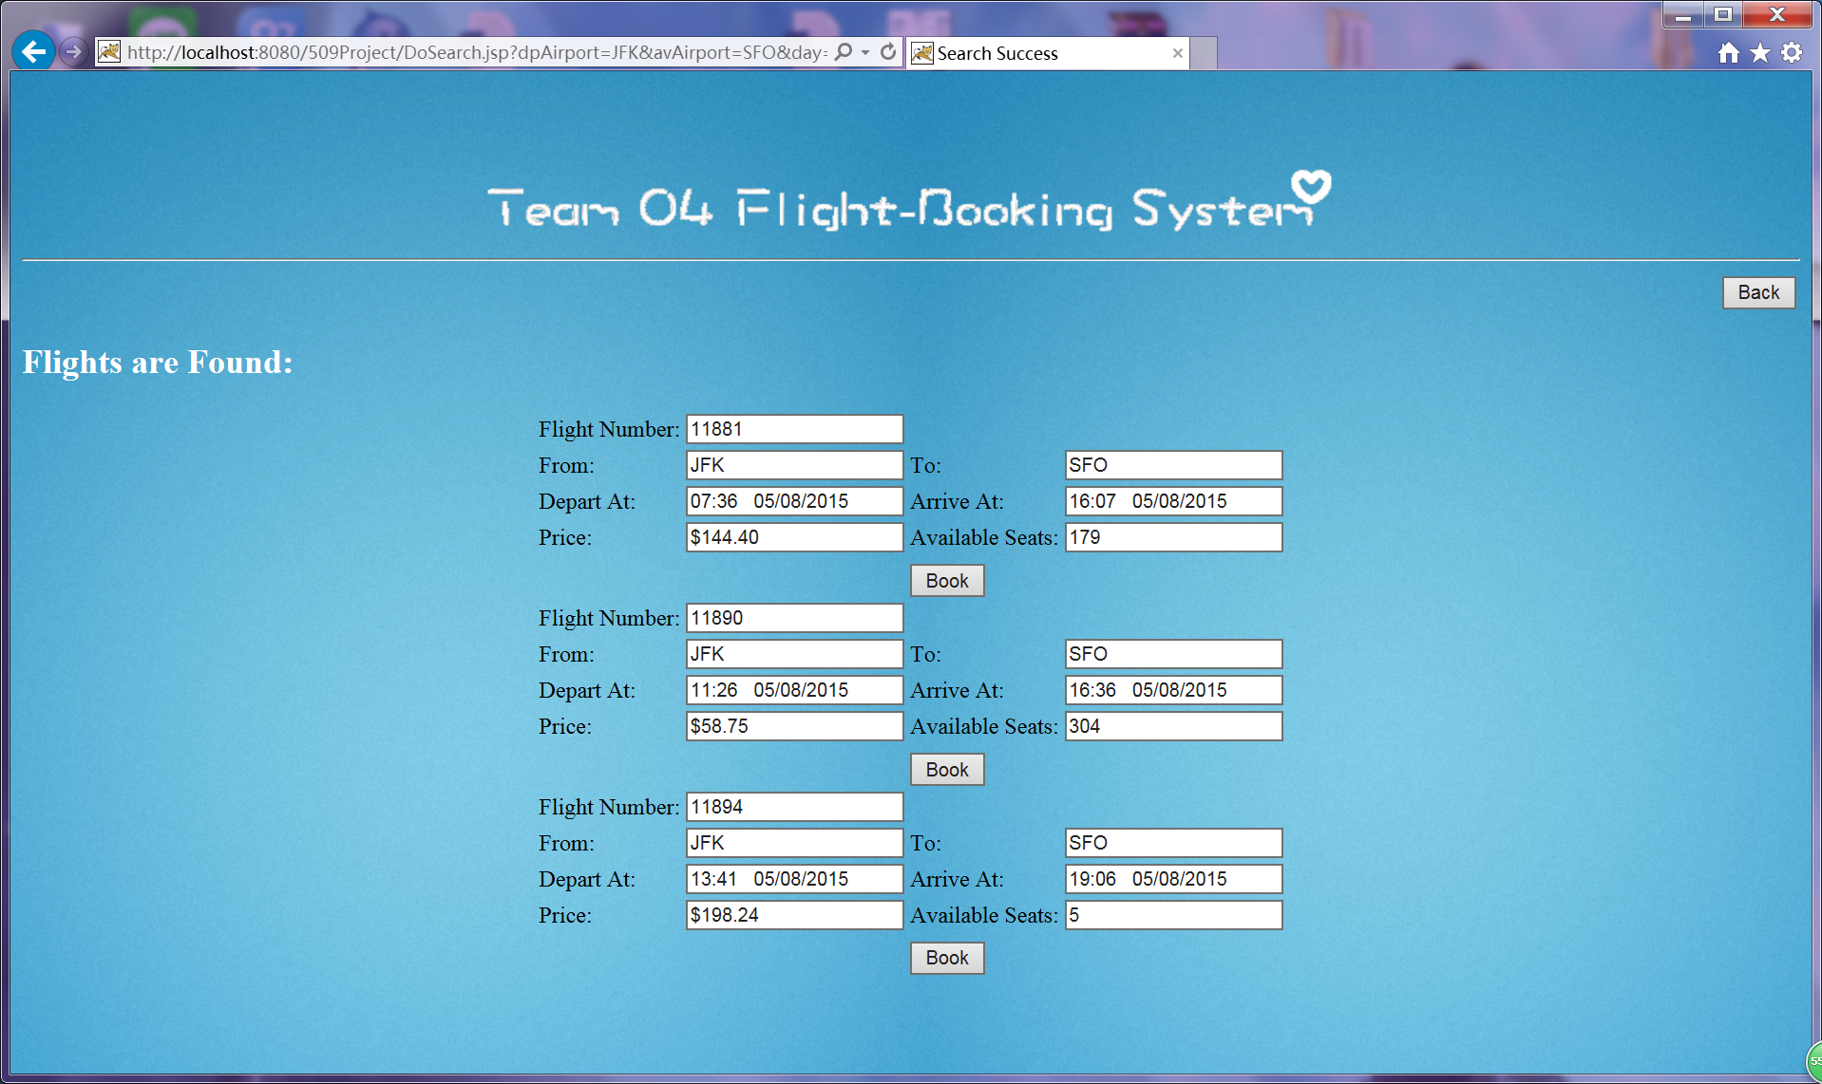

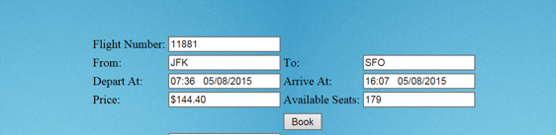

c. Server has received our requirement:

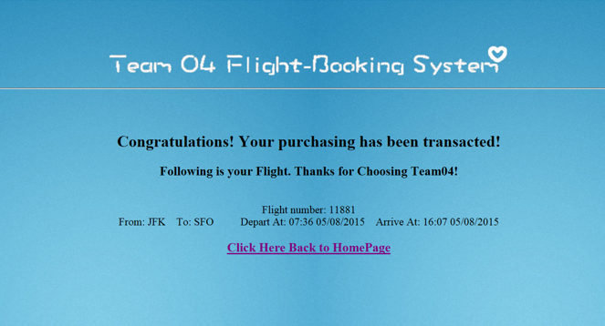

d. Data verify:

If we re-enter the same option and then searching we can find the seat number has changed to 13. So it can provide that our purchase is indeed success.

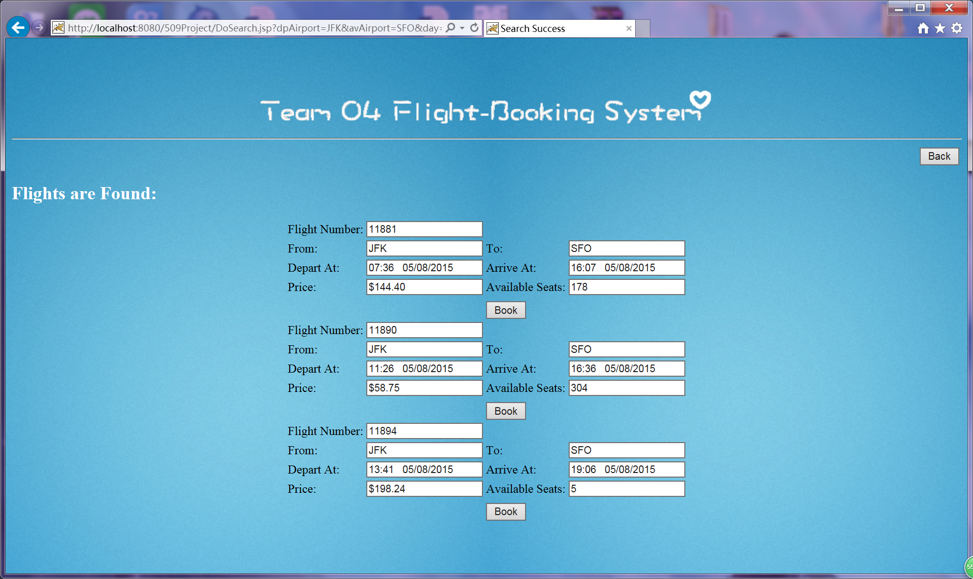

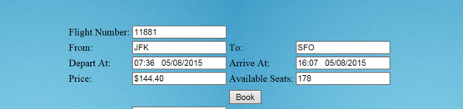

**Round-trip:**

It is same to the process of One-Way:

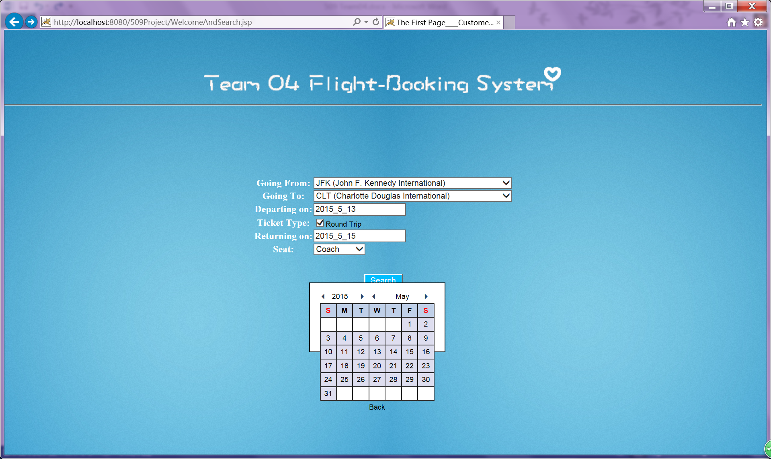

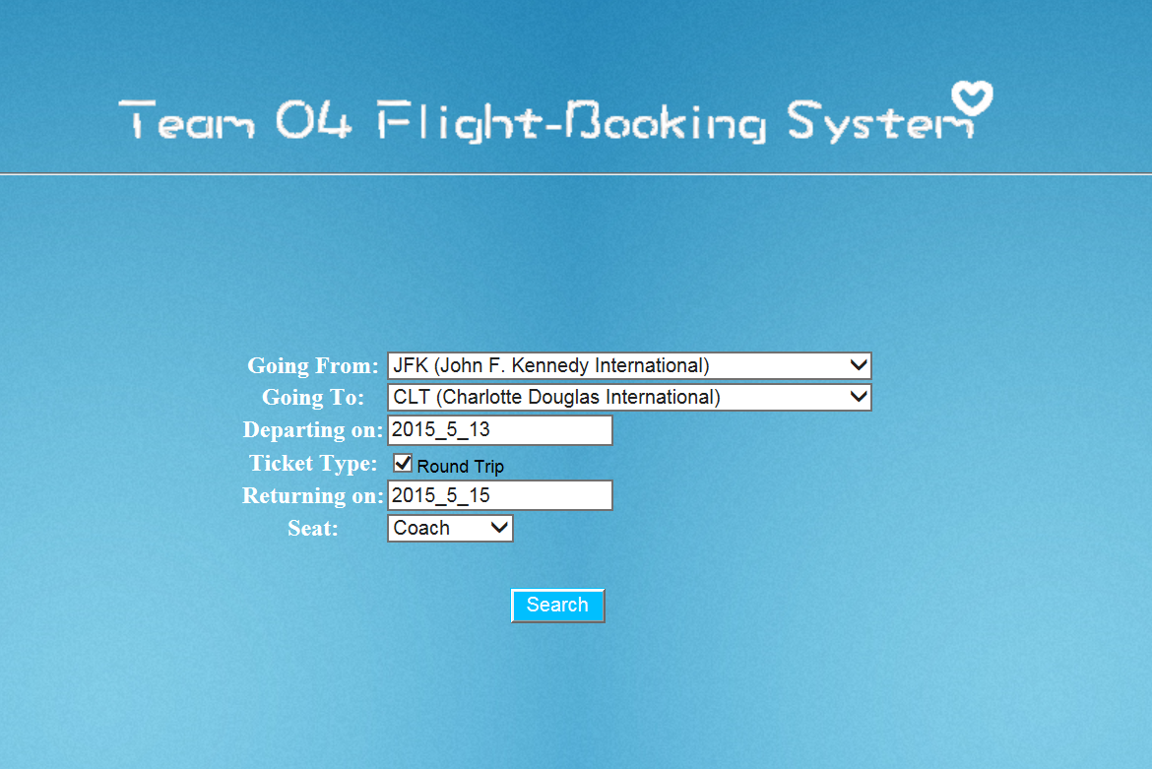

The depart flight seat number is 197, the return flight seat number is 80

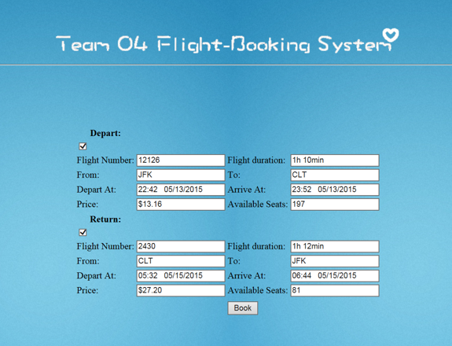

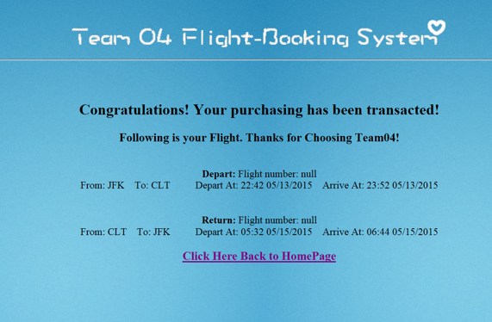

If we input the same information we can find each seat number has subtracted 1.

